UIA World Congress, Durban 2014
DECLARATION 2050 IMPERATIVE

Recalling the Chicago Declaration of Interdependence for a Sustainable Future (18-21 June 1993) which recognized our ecological interdependence with the whole natural environment and committing to place environmental and social sustainability at the core of our practice and professional responsibilities.

Also recognizing the importance of the Post-2015 Development Agenda and the Sustainable Development Goals process to achieve a sustainable future; in particular, supporting a stand-alone goal to “make cities and human settlements inclusive, safe, resilient and sustainable".

Recalling the United Nations Framework Convention on Climate Change (UNFCCC) conference that will reconvene in Paris in 2015 with the goal of reaching a new agreement on phasing out CO2 emissions from worldwide power and industrial sectors by 2050, and all GHG emissions from energy systems by the second half of the 21st century.

Recognising that urban areas are responsible for over 70% of global energy consumption and CO2 emissions, mostly from buildings. Over the next two decades, an area roughly equal to 60% of the total building stock of the world is projected to be built and rebuilt in urban areas worldwide. This provides an unprecedented opportunity to reduce fossil fuel CO2 emissions by setting the global building sector on a path to phase out CO2 emissions by 2050.

We recognize our responsibility to seize this unique opportunity to influence ethical and socially responsible development throughout the world: to plan and design sustainable, resilient, carbon-neutral and healthy built environments that protect and enhance natural resources and wildlife habitats, provide clean air and water, generate on-site renewable energy, and advance more livable buildings and communities.

By adopting the 2050 IMPERATIVE at the International Union of Architects (UIA) World Congress in Durban, the UIA and its member organizations and partners will send a strong message to the Parties of the UNFCCC, and to the world, that we are committed to a truly sustainable and equitable future.

The UIA is acutely aware that failing to act now on climate change will put future generations and those already affected by extreme weather, natural disasters, and poverty, at great risk.

Recognizing the architects' central role in planning and designing the built environment, and the need to reduce carbon emissions to zero by 2050 and provide equal access to shelter, we commit to promote the following actions;

- Plan and design cities, towns, urban developments and new buildings to be carbon neutral, meaning they use no more energy over the course of a year than they produce, or import, from renewable energy sources.
- Renovate and rehabilitate existing cities, towns, urban redevelopments and buildings to be carbon neutral whilst respecting cultural and heritage values.
- In those cases where reaching carbon neutral is not feasible or practical, plan and design cities, towns, urban developments, new buildings and renovations to be highly efficient with the capability to produce, or import, all their energy from renewable energy sources in the future.
- We commit to the principle of engaging in research and setting targets towards meeting the 2050 goal.
- Advocate and promote socially responsible architecture for the community, develop and deliver equitable access to the information and tools needed to:
  - plan and design sustainable, resilient, inclusive and low-carbon/zero carbon built environments.
  - design no-cost/low-cost on-site renewable energy and natural resources systems (e.g., passive heating and cooling, water catchment and storage, solar hot water, daylighting, and natural ventilation systems).

Signatories:
UIA - International Union of Architects
UIA Young Architects
ARCASIA - Architects Regional Council Asia
AUA - African Union of Architects
ACE - Architects Council of Europe
FPAA - Federacion Panamericana de Asociaciones de Arquitectos
CAA - Commonwealth Association of Architects
UMAR - Union Mediterraneenne des Architectes
CIALP - Conselho Internacional dos Arquitectos de Lingua Portuguesa
DoCoMoMo - Docomomo International
ICOMOS- International Council on Monuments and Sites
FAU - Fondation des Architectes de I'Urgence
CA - Canberra Accord
AHA - Active House Alliance
WGBC - World Green Building Council

Supporting Organization: Architecture 2030

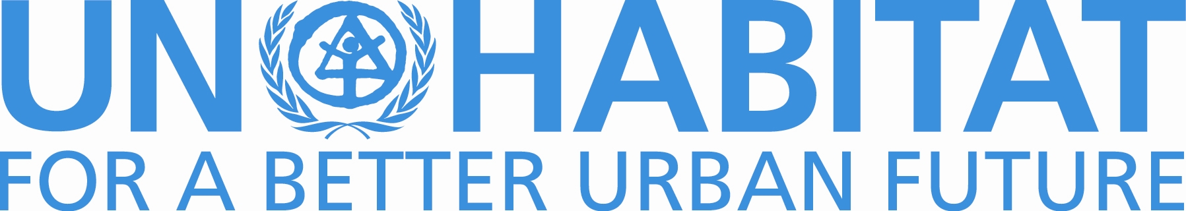
Endorsed by UN-Habitat recognizing the critical role of architects in the implementation of the Post 2015 Development Agenda and in the definition of the New Urban Agenda at the Third United Nations Conference on Housing and Sustainable Urban Development (Habitat III) to be held in 2016.

